EXPLORE THE WORLD WITH SHEAFE’S FLAT BLUEBIRD
Due: Friday, March 9, 2012
STUDENT NAME: _________________________________________________ ROOM _______________
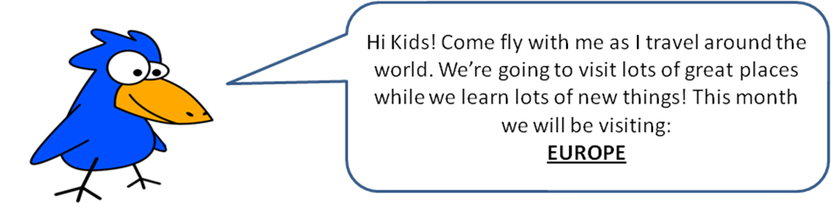
Thanks for staying on my world journey with me. This month, I’m heading to Europe.
Europe is the second smallest continent in the world, by size. Yet, it has a lot of different cultures. Europe also controls a large amount of the world’s political and financial decisions.
While in Europe, I will be visiting some different countries. Let’s start in the northwest on the country of Iceland. Iceland is an island country. An island is a body of land that is completely surrounded by water. From Iceland, I’m going to travel southeast. I’ll fly in to the country of Ireland (also an island). I’ll spend a few days there and then travel east to Great Britain (also know as England). From Great Britain, I’ll fly south to France. Maybe I’ll fly to Paris and visit the Eiffel Tower! ☺
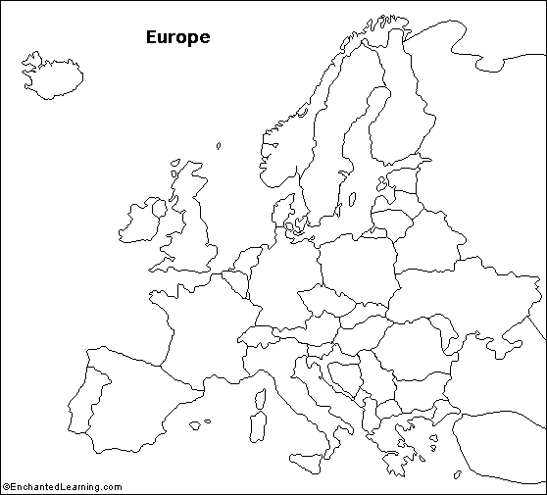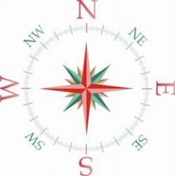
Color and label the flags for Ireland and Great Britain.
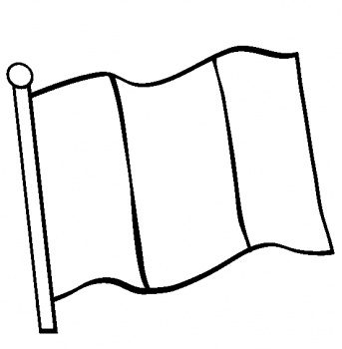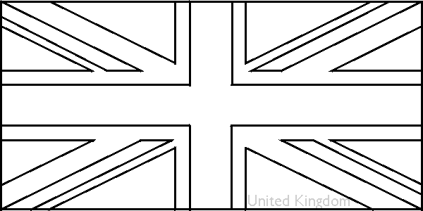

Using the information above and the compass rose, color and label the following countries:
Iceland – yellow
Ireland – green
Great Britain – red
France -- pink

The flag of Ireland is green, white and orange. Green is closest to the pole, white is in the middle. Orange is the color farthest from the pole.
The flag of Great Britain is red, white and blue. The “t” in the middle is red. The middle section in each corner is also red. The triangles are blue. The rest of the flag is white.

Europe is generally divided to its east from the continent of Asia by the Ural and Caucasus Mountains, the Ural River, the Caspian and Black Seas, and the waterways connecting the Black and Aegean Seas.
- Draw the eastern border of Europe in red ----------------
- Label the following: Ural Mountains, Caucasus Mountains, Black Sea, Caspian Sea, and Aegean Sea.

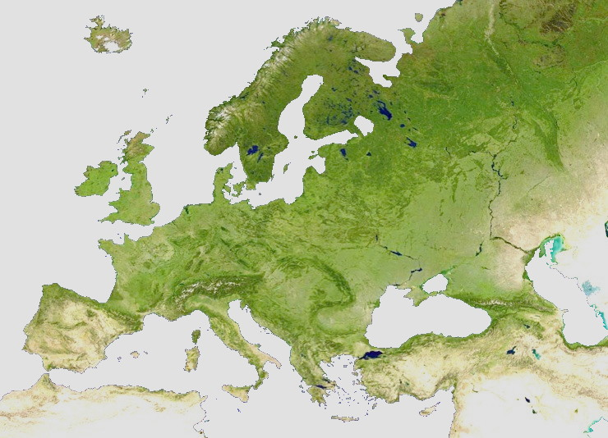

Europe is bordered to the north by the Arctic Ocean.
Europe is bordered to the west by the Atlantic Ocean.
Europe is bordered to the south by the Mediterranean Sea.
- Label the Arctic and Atlantic Oceans and Mediterranean Sea.
- Color the oceans and seas blue.

